UBITX V6 2.8” NEXTION TFT DISPLAY MODIFICATION

I received my UBITX V6 from HF signals a week ago and the first thing I noticed was the slow display refresh. I wanted to adapt a nextion display and it worked.
So here is the modification to adapt a nextion 2.8” display to Ubitx V6:
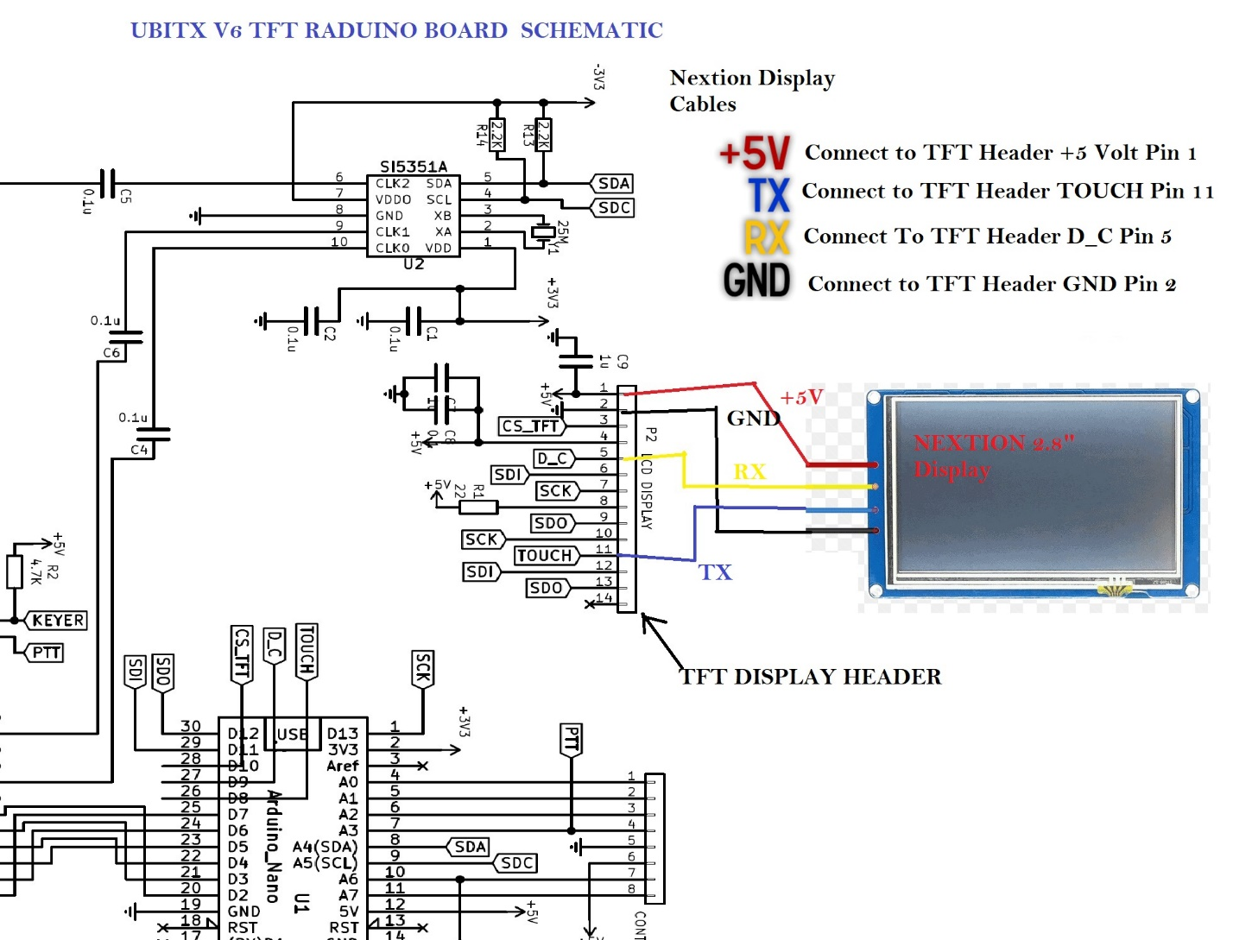

I removed the stock TFT and replaced with Nextion 2.8’ TFT display.
To make the necessary connections I used 90 degree male header pins.

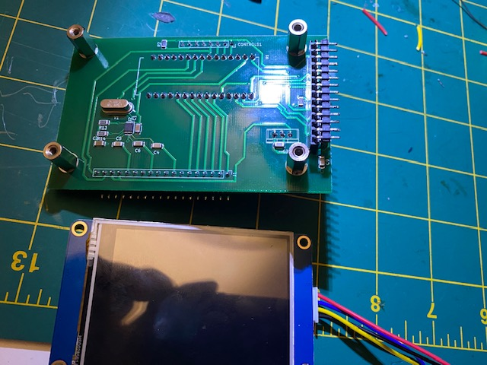

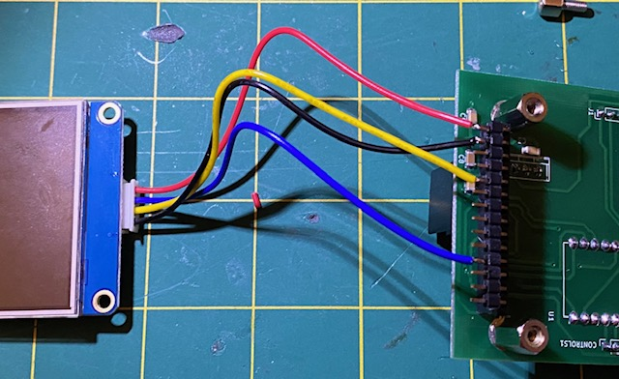

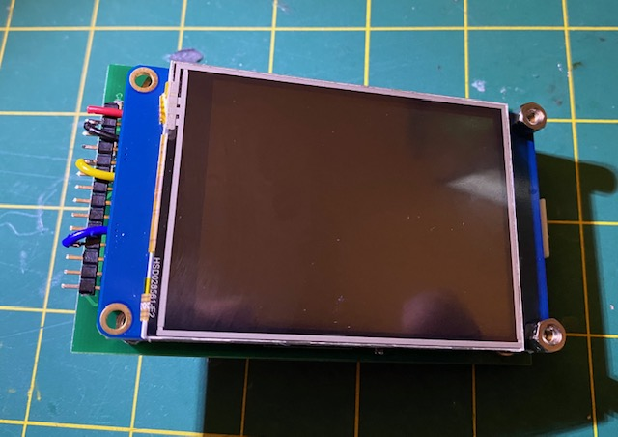

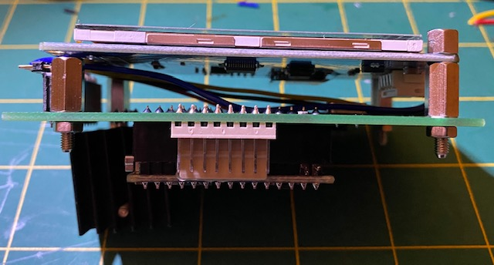
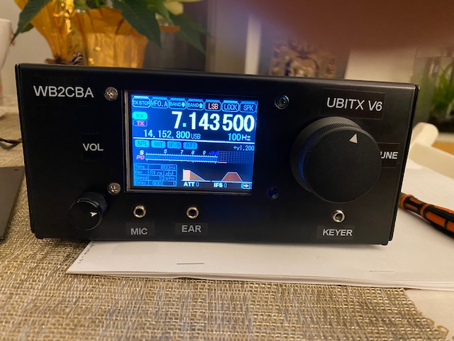

For firmware I used KD8CEC Ian Lee’s CEC Firmware Version 1.2 for Ubitx V5 from below link:
http://www.hamskey.com/2019/04/release-cec-firmware-v1200-for-ubitx.html
As Ubitx V6 is a apart from a new PCB design same as Ubitx V5, all works fine as it would on a Ubitx V5. The only glitch is mechanical. The right two spacers can’t be screwed in as it stands. Two left spacers are holding the display pretty tight though.

73’s,

WB2CBA – Barbaros Asuroglu

